MORNING WORSHIP SERVICE
Oct 04, 2015

Opening Song “Standing in the Need of Prayer”

Opening Prayer/Announcements

Worship Hymns “At Calvary” 138
“Blessed Redeemer” 149
“Freely, Freely” 276
“Holy, Holy, Holy” 2
“Holy Is the Lord” 9

Offering/Offertory

Special Music

Message Bro. David Atwood
.
Invitation “Just As I Am” 307

High Attendance Sunday – Oct 25th
Join us and bring a friend or 2
Closing Prayer

Evening Service at 6:00

Living Proof Live
March 4-5, 2016 (Fri & Sat)
Waco, TX: Extraco Event Center
Contact Patti Radford if you might be interested in attending

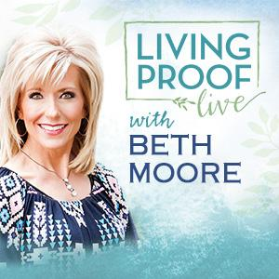
NURSERY – available for children age 0 to Kindergarten
Patti Radford & Garlyn Radford

Hostesses for October Ushers for October
Diann Stutes, Evelyn Robinson, Sam McManus, Wesley McManus,
Hugo & Carolyne Breithaupt Joe Wilson, Bobby Stutes

Immediate Need Prayer List
Prayer & Request Information

(Please complete name & address information on reverse side)

I would like to speak with the Pastor.

I would like more information on this church.

I have Prayer Requests or Needs

Date:

Permission to Publicize:
Church Bulletin Yes No
Email Prayer Chain Yes No

Prayer Request:

Prayer For
Name
Address
Phone

Given By
Name
Address
Phone
Please Contact By

Card Phone Visit

Comments

Pray for those who are ill

Pray for unsaid needs

K s b c

Keeping His Word through Sunday School, Bible Study and Church Attendance/Worship

Sunday School Bible Studies for October:

Oct 4th God’s Promise of Victory Romans 8:28-39 Oct 11th God’s Promise of A New Home Revelation 21:1-8
Oct 18th Develop Conviction Daniel 1:3-5,8-13,17-19
Oct 25th Pray Fervently Daniel 2:13-21,26-28a

9:45 a.m. each Sunday – A place for everyone

WE’D LOVE FOR YOU TO JOIN US!

